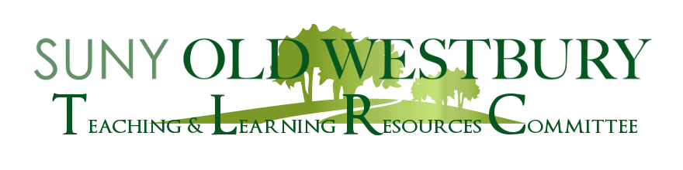

**SAVE THE DATE**

**Artificial Intelligence and Academic Integrity**

A Roundtable led by:

**Kyle Anderson, History & Philosophy**

**and**

**Mohamed Khalefa, Math/CIS**

**Tuesday, February 7th**

**2:40 pm- 3:40 pm**

**NAB 1107**

**We will also include participation via Zoom.**

**Meeting ID: 649 730 1026**

**Passcode 2723**

Please join us for the first in a series of workshops on Artificial Intelligence in Academia where we will discuss current and future developments in AI and their implications for academic integrity, as well as strategies for addressing and mitigating these challenges.